Sensitivity Uncertainty Multimedia Modeling Module Test Plan

1.0 Background and Scope

The purpose of the Sensitivity Uncertainty Multimedia Modeling Module (SUM³) is to perform sensitivity and uncertainty analyses on a group of environmental model variables selected by the user. A sensitivity analysis estimates the sensitivity of an output variable to changes in the value of an input variable. The results can be used to rank the importance of input variables and to prioritize data collection to better define the value of input variables. An uncertainty analysis provides an estimate of the probability distribution of an output variable as a function of one or more input variables modeled as random variables. The probability distributions represent the uncertainty in the values of the input and output variables. The results of an uncertainty analysis can be used, for example, to estimate the probability that a receptor’s dose is greater than a regulatory limit.

The module contains a user interface that provides for the selection of variables to be included in the sensitivity/uncertainty analysis and for the specification of distribution type (e.g., lognormal) and distribution parameters (e.g., mean and variance, upper and lower bounds). The distribution type for each selected input variable is chosen from a standard list. The user interface also provides for the input of correlations between selected parameters and for the specification of an optional transformation to be carried out on an input variable. This transformation permits the use of non-standard probability distributions.

SUM³ generates realizations of the random input variables using LATIN, a code that implements a Latin hypercube sampling method.

SUM³ also processes the output from the uncertainty analysis. Output results from each module are available to the user as uncertainty analysis results. Only results selected by the user are saved for each realization.

The testing described in this plan is black box, which is an appropriate level for testing the integrated operation of the SUM³.

- Requirements

Table 1. Requirements for the SUM³
Requirement Number | Requirement
1 | have a user-friendly interface with the following characteristics:  - standard Windows 95 look and feel  - a brief description of each input variable for which a distribution can be selected is provided  - a display of the bounding values for the input variables
2 | function correctly when connected to one or more modules
3 | allow the user to select those input variables to be included in the sensitivity or uncertainty analysis (these will be referred to here as selected variables).
4 | require the user to provide an alias for all input and output variable choices.
5 | allow the user to specify a distribution type for each selected variable from a list containing the following distribution types:  - Uniform  - Log Uniform  - Normal  - Log Normal
6 | prompt the user for input specifying the parameters of the distribution for each selected variable; these parameters will be a function of the distribution type.
7 | allow the user to enter an expression, for each selected variable, that will be used to transform the generated values of the selected variable before they are used in other modules; if no expression is entered, the variable will not be transformed.
8 | allow the user to return any selected variable to its initial, constant value at any point before the sensitivity or uncertainty computations are begun.
9 | allow the user to specify a correlation coefficient for any two selected variables; each selected variable can be correlated with multiple other selected variables.
10 | allow the user to specify the number of iterations (realizations) generated by LATIN with an upper limit of 500 iterations.
11 | correctly perform calculations that transform a selected input variable or that derive a non-selected variable value given the value of one or more selected variables. These transformations and functional relationships will be input by the user.
12 | generate distributions for the selected input variables that statistically approximate the distributions specified by the user, including any correlations between variables.
13 | execute the appropriate environmental models using the correct combinations of randomly generated (and functionally dependent) variable values for the number of realizations specified by the user.
14 | allow the user to select the output variables to be viewed; these must include, but are not limited to:  - constituent mass flux in air or water  - constituent concentration in air or water  - dose  - risk or hazard quotient
15 | allow the user to save the sensitivity and/or uncertainty analysis using a user-specified filename
16 | handle module and SUMMM errors appropriately
17 | be capable of reading results from wff, wcf, and hif files
18 | be capable of reporting peak cumulative dose results (all contaminants, all pathways) when connected to the health impacts module
19 | provide appropriate output choices for each module type
20 | allow the user to select results for radionuclide parents and progeny separately and correctly report those results

These requirements are tested through test cases. Specific requirements tested by each case are illustrated in the following table.

Table 2. Requirements/Test Case Matrix
 | Test Case
Req. # | 1 | 2 | 3 | 4 | 5 | 6 | 7 | 8 | 9 | 10
1 | X
2 | X | X
3 | X
4 | X |  |  |  | X | X | X | X
5 | X |  |  |  | X | X | X | X
6 | X |  |  | X
7
8 | X |  |  | X
9
10 | X |  |  |  |  |  | X
11 |  |  |  |  | X | X | X | X
12 |  |  | X
13 | X | X | X
14 | X | X
15 | X
16 |  |  | X |  |  |  |  |  |  | X
17 | X | X
18 |  |  |  |  |  |  |  |  | X
19 | X
20 |  | X

3.0 Test Cases

3.1 Sum3_01

3.1.1 Description and Rationale

This case verifies that SUM3 is meeting its basic functionality requirements. Only the contaminant selection and source term modules will be used along with the SUM3 module. The constituent benzene was selected for this case.

Because this is a test for basic functionality, many requirements will be addressed through this case. The requirements addressed are listed below. These requirement numbers are referenced in the Observed Results section. (Note: the requirement numbers used below do not correspond to the requirement numbers listed in Table 1.)

- have a user-friendly interface with the following characteristics:
- standard Windows 95 look and feel
- a brief description of each input variable for which a distribution can be selected is provided
- function correctly when connected to one or more modules
- allow the user to select those input variables to be included in the sensitivity or uncertainty analysis (these will be referred to here as selected variables).
- require the user to provide an alias for all input and output variable choices.
- allow the user to specify a distribution type for each selected variable from a list containing the following distribution types:
- Uniform
- Log Uniform
- Normal
- Log Normal
- prompt the user for input specifying the parameters of the distribution for each selected variable; these parameters will be a function of the distribution type.
- allow the user to return any selected variable to its initial, constant value at any point before the sensitivity or uncertainty computations are begun.
- allow the user to specify the number of iterations (realizations) generated by LATIN with an upper limit of 500 iterations.
- allow the user to select the output variables to be viewed; these must include, but are not limited to:
- constituent mass flux in air or water
- constituent concentration in air or water
- dose
- risk or hazard quotient
- allow the user to save the sensitivity and/or uncertainty analysis using a user-specified filename
- be capable of reading WFF files
- provide appropriate output choices for each module type

The above requirements are basic functions of SUM3 that will need to be met by other test cases, however, they will only be checked specifically in this test case. Going through the process of setting up the test case will check all of these requirements.

    - Input Data

This section lists the input parameter values for this case. The contaminant benzene will be used as the contaminant for this test case. The following tables list the input for the MEPAS Computed Source Term Module (CSTRM):

Tab Name: Options
Description | Parameter Name | Parameter Value | Unit
Source term media | STMEDIA | Soil/Vadose | none
Leaching | STINF_OP | Known infiltration rate | none
Overland runoff | STOVL_OP | Turn off pathway | none
Suspension | STSUS_OP | Turn off pathway | none
Volatilization | STVOL_OP | Turn off pathway | none
Source/sink | STSRC_OP | Turn off pathway | none
Time interval for first 100 yrs | STDELTA_T | 1 | nears
Length of run | STMAXTIME | 100 | years
Minimum waste fraction | STMINWST | 0.01 | fraction

Tab Name: Waste Zone
Description | Parameter Name | Parameter Value | Unit
Depth to top of waste zone | STCLEAN | 0 | cm
Thickness of waste zone | STTHICK | 10 | m
Length of waste zone | STLENGTH | 10 | m
Width of waste zone | STWIDTH | 10 | m
Bulk density of soil | STZBULKD | 1.4 | g/cm3
Total porosity | STTOTPOR | 43.7 | percent
Moisture content | STMOISTC | 6 | percent
Volumetric air content | STAIRSPC | 37.7 | percent
Average air temperature at the waste site | STAVTEMP | 25 | C
Height above ground of local wind measure | STWINDHT | 10 | meters

Tab Name: Kds
Description | Count | Parameter Name | Parameter Value | Unit
equilibrium coefficient | 2 | STKD | 0.0 | ml/g
 |  | STKD | 0.0 | ml/g

Tab Name: Contaminant Properties
Description | Parameter Name | Parameter Value | Unit
water solubility | STSOL | 1750.0 | mg/L
contaminant inventory (use worksheet) | STINVEN | 1000.0 | g
decay/degradation half life | STGHALF | 0.0 | day

Tab Name: Known Media Releases
Description | Parameter Name | # of Measurements | Parameter Value | Year of Measurement | Unit
darcy infiltration rate | STDARCY | 2 | 10 | 0 | cm/yr
 |  |  | 10 | 100

The following tables list the input for SUMMM:

Tab Name: Variables
Description |  |  | alias
equilibrium coefficient, Benzene, Time # 1… |  |  | Kd1
Tab Name: Parameters
Subtab: Distribution (Correlations and Equation tabs will not be used)
Alias | Description | Distribution |  | Parameter Value | Unit
Kd1 | Upper bound | Uniform |  | 10.0 | ml/g
Kd1 | Lower bound |  |  | 0.01 | ml/g
Tab Name: Outputs
Description |  | Parameter Value |  | Unit
Random seed value |  | 11301 |  | none
Number of iterations |  | 10 |  | none
Water constituent flux peak from Source |  | (alias) flux |  | none

    - Instructions for performing the test

For this test case, the basic functions of the SUM3 will be tested. This test case will involve adding a sensitivity/uncertainty module to an existing case, entering the required SUM3 data, and running SUM3. General instructions for setting up a case and using FRAMES are located in Appendix A. They should be referenced if necessary. A detailed description of how to start up and execute this case will not be included here.

- Bring up the FUI and use the File menu to open the case SUM3_01.GID. It will be located in the folder labeled SUM3_01.
- The case SUM3_01.GID that should contain a contaminant selection and source term icon in the working space. The contaminant benzene has already been selected and the source term data has been entered already.
- Add a sensitivity/uncertainty module icon to the working space.
- Connect the source term icon to the sensitivity/uncertainty icon.
- For the sensitivity/uncertainty model, select the MEPAS Sensitivity/Uncertainty Module.
- Right click on the sensitivity/uncertainty icon and choose 'User Input' to bring up the SUM3 user interface.
- On the 'Variables' tab, all parameters available for use in the SUM3 run are briefly described in the 'Variable Description' list. Search the list until you find 'equilibrium coefficient, Benzene, Time # 1 from Source_1(src9)'. Click on it to highlight it. Then type in 'kd1' in the box at the top of the tab. To the right of the box will be the label 'Alias'. This is where you enter an alias for the input variables that will be used in the SUM3 run. After typing in 'kd1', click on the 'Add' button. The alias should appear in the window below next to the variable description.
- Remaining on the 'Variables' tab, use the same process to find the variable description 'water solubility, 71432, Benzene from Source_1(src9)'. Give it the alias 'WaterSol' by typing in the 'alias' input box and clicking on the 'Add' button. As before, the alias should appear in the window below next to the variable description. While the parameter is still highlighted, hit the 'delete' button. The alias next to the parameter should disappear. The 'delete' button can be used to its initial, constant state before the SUM3 run is begun.
- Next specify the distribution for the parameter 'kd1'. Click on the 'Parameters' tab. The 'kd1' parameter will be highlighted because it is the only input parameter specified. In the 'Distribution' tab, there should be a list box next to the label 'Type'. This is where you will specify the distribution type for the parameter 'kd1'. Click on the arrow on the right side of the list box to view the distribution choices. The choices listed should be 'None', 'Uniform', 'Log Uniform', 'Normal', and 'Log Normal'. For this case, select 'Uniform'. After the distribution type is selected, input boxes will appear for the required distribution data. In this case, an input box for the upper and lower bound of the distribution type should appear. Type in the input data listed in the input data section 3.1.2. Enter 10.0 for the upper bound and 0.01 for the lower bound. No correlations or equations will be used in this test case.
- Next specify the output parameter and some run parameters. Click on the 'Outputs' tab. For the random seed value, change the default value of '1' to '11301'. For the number of iterations, change the default value from '1' to '10'. Next select the output variable. Search the 'Output Description' list until you find 'Water constituent flux peak from Source_1(src9) for benzene'. Click on it to highlight it. Then type in 'flux' in the box to the right of the label 'Alias'. This is where you enter an alias for the input variables that will be used in the SUM3 run. After typing in 'flux', click on the 'Add/Change' button. The alias should appear in the window below next to the output description.
- All required input for the SUM3 run has been entered. Use the file pull-down menu at the top left of the SUM3 screen to save and exit. The signal light on the sensitivity/uncertainty icon should now be yellow indicating that all input has been entered and the module can be run. Right click on the icon and select 'Run Model'.
- After the run has completed, add a viewer to the work space and connect it to the sensitivity/uncertainty icon. Select the 'SUF Viewer' for the model type. Right click on the viewer icon and select 'Run Model'. The text of the SUM3 output file should appear. Check that all 10 iterations were completed successfully. The actual numbers are not important for this case.
- Save and exit this case.

3.1.4 Expected Results

It is expected that SUM3 will meet all of the requirements described in section 3.1.1.

3.1.5 Observed Results

- SUM3 has a user-friendly interface with the following characteristics:
- standard Windows 95 look and feel
- a brief description of each input variable for which a distribution can be selected is provided
- SUM3 functioned correctly when connected to one or more modules
- SUM3 allowed the user to select those input variables to be included in the sensitivity or uncertainty analysis (these will be referred to here as selected variables).
- SUM3 required the user to provide an alias for all input and output variable choices.
- SUM3 allowed the user to specify a distribution type for each selected variable from a list containing the following distribution types:
- Uniform
- Log Uniform
- Normal
- Log Normal
- SUM3 prompted the user for input specifying the parameters of the distribution for each selected variable; these parameters will be a function of the distribution type.
- SUM3 allowed the user to return any selected variable to its initial, constant value at any point before the sensitivity or uncertainty computations are begun.
- SUM3 allowed the user to specify the number of iterations (realizations) generated by LATIN. In this case, 10 iterations were specified.
- SUM3 allowed the user to select the output variables to be viewed; these must include, but are not limited to:
- constituent mass flux in air or water
- constituent concentration in air or water
- dose
- risk or hazard quotient
- SUM3 allowed the user to save the sensitivity and/or uncertainty analysis using a user-specified filename
- SUM3 was able to read a WFF file. The ability to read other file types will be checked in other test cases.
- SUM3 provided appropriate output choices for each module type.

3.2 SUM3_02

3.2.1 Description and Rationale

The purpose of this case is to test some additional basic module requirements. The FRAMES Known Contaminant Flux or Concentration model and the MEPAS Saturated Zone Module were used. The contaminants selected were Strontium-90 and Yttrium-90. The specific requirements checked are listed below. These requirement numbers are referenced in the Observed Results section. (Note: the requirement numbers used below do not correspond to the requirement numbers listed in Table 1.)

- function correctly when connected to one or more modules
- execute the appropriate environmental models using the correct combinations of randomly generated (and functionally dependent) variable values for the number of realizations specified by the user.
- allow the user to select the output variables to be viewed; these must include, but are not limited to:
- constituent mass flux in air or water
- constituent concentration in air or water
- dose
- risk or hazard quotient
- be capable of reading WCF files
- provide appropriate output choices for each module type
- allow the user to select results for radionuclide parents and progeny separately and correctly report those results

3.2.2 Input Data

This section lists the input parameter values for this case. The contaminants Strontium-90 (Sr-90) and Yttrium-90 (Yt-90) will be used as the contaminants for this test case. The following table lists the input for the FRAMES Known Contaminant Flux or Concentration model:

Water Flux Tab
Parameter | Value | Units
Type of contaminant medium | vadose | none
Width of flux plane | 10 | m
Length of flux plane | 10 | m
Distance below water surface | 0 | m
Natural recharge rate | 1 | m/yr
Initial water flux time | 0 | yr
Initial water flux | 10 | m^3/yr
Ending water flux time | 5 | yr
Ending water flux | 10 | m^3/yr
Initial Sr90 flux time | 0 | yr
Initial Sr90 flux | 100 | pCi/yr
Ending Sr90 flux time | 5 | yr
Ending Sr90 flux | 100 | pCi/yr
Initial Yt90 flux time | 0 | yr
Initial Yt90 flux | 1000 | pCi/yr
Ending Yt90 flux time | 5 | yr
Ending Yt90 flux | 1000 | pCi/yr

The following tables list the input for MEPAS Saturated zone Module

Soil Composition Tab
Parameter | Value | Units
Percentage of sand | 83 | %
Percentage of silt | 11 | %
Percentage of clay | 6 | %
Percentage of organic matter | 0 | %
Percentage of iron and aluminum | 0 | %

Characteristics Tab
Parameter | Value | Units
Percent constituent flux entering aquifer | 100 | %
pH of the pore water | 7 | pH
Total porosity | 43.7 | %
Effective porosity | 12 | %
Darcy Velocity | 100 | cm/day
Thickness of aquifer | 1000 | cm
Longitudinal dispersivity | 1 | cm
Dry bulk density | 1.49 | g/cm^3

Concentration Locations Tab
Parameter | Value | Units
Usage location – use default | fcm4 | none
Longitudinal distance to flux location | 5000 | cm
Perpendicular distance from plume centerline to well | 0 | cm
Vertical distance below water table to well intake | 0 | cm
Longitudinal dispersivity | 500 | cm
Transverse dispersivity | 165 | cm
Vertical dispersivity | 1.25 | cm

Constituent Parameters Tab
Parameter | Value | Units
Sr90 Adsorption Coefficient | 24.3 | ml/g
Yt90 Adsorption Coefficient (progeny and parent) | 0 | ml/g

The following tables list the input for MEPAS Saturated zone Module

Exposure Controls Tab
Parameter | Value | Units
Time to start exposure computation | 0.0 | yr
Maximum time for reporting | 100.0 | yr
Number of time points for evaluation | 4 | none

Ground Water Tab
Parameter |  |  | Value | Units
Exposure duration |  |  | 25.0 | yr
Pathways Subtab |  | Water Usage Subtab
Drinking water | X | Domestic water is treated

The following tables list the input for SUM3:

Tab Name: Variables
Description |  |  | alias
Width/Height for Vadose/Aquifer of source, … |  |  | SrcWidth
Soil equilibrium coefficient, STRONTIUM-90… |  |  | Kd_Sr90
Tab Name: Parameters
Subtab: Distribution (Correlations and Equation tabs will not be used)
Alias | Description | Distribution |  |  | Parameter Value |  | Unit
SrcWidth | Upper bound | Uniform |  |  | 15.0 |  | m
SrcWidth | Lower bound |  |  |  | 5.0 |  | m
Kd_Sr90 | Upper bound | Uniform |  |  | 30.0 |  | ml/g
Kd_Sr90 | Lower bound |  |  |  | 20.0 |  | ml/g
Tab Name: Outputs
Description |  | Parameter Value |  |  | Unit
Random seed value |  | 11301 |  |  | none
Number of iterations |  | 10 |  |  | none
Description |  |  |  | Alias |  | Unit
Water concentration peak from aqu2 for STRONTIUM-90 |  |  |  | Sr90peak |  | none
Water concentration peak from aqu2 for YTTRIUM-90 (STRONTIUM-90) |  |  |  | Yt90Pro |  | none
Water concentration peak from aqu2 for YTTRIUM-90 |  |  |  | Yt90Par |  | none

    - Instructions for performing the test

For this test case, some additional basic functions of the SUM3 will be tested. General instructions for setting up a case and using FRAMES are located in Appendix A. They should be referenced if necessary. A detailed description of how to start up and execute this case will not be included here.

- Bring up the FUI and use the File menu to open the case SUM3_02.GID. It will be located in the folder labeled SUM3_02.
- Open up the case SUM3_02.GID that should contain a contaminant selection, source term, saturated zone, and sensitivity/uncertainty icons in the working space. The contaminant benzene has already been selected and the source term, saturated zone, and SUM3 data have been entered already.
- Check the data entered for the source term and saturated zone modules to ensure that it matches the data listed in section 3.2.2 above. Make corrections if necessary.
- Check the data entered for SUM3 to ensure that it matches the data listed in section 3.2.2 above. Make corrections if necessary.
- Run the source term, saturated zone, and exposure modules to get green lights for each. This should be done even if the lights are already green. Then run SUM3.
- After the run has completed, use the viewer connected to the sensitivity/uncertainty icon to check that all 10 iterations were completed successfully. The actual numbers are not important for this case.
- Save and exit this case.

    - Expected Results

It is expected that SUM3 will meet all of the requirements described in section 3.2.1.

3.2.5 Observed Results

- SUM3 functioned correctly when connected to one or more modules.
- SUM3 executed the appropriate environmental models using the correct combinations of randomly generated (and functionally dependent) variable values for the number of realizations specified by the user.
- SUM3 allowed the user to select the output variables to be viewed; these must include, but are not limited to:
- constituent mass flux in air or water
- constituent concentration in air or water
- dose
- risk or hazard quotient
- SUM3 was capable of reading WCF files
- SUM3 provided appropriate output choices for each module type.
- SUM3 allowed the user to select results for Yttrium-90 as a parent and progeny separately and correctly report those results

3.3 SUM3_03

3.3.1 Description and Rationale

This case tests the ability of SUM³ to iterate on and read the file types associated with the health impact modules available in FRAMES. The FRAMES Known Contaminant Flux or Concentration, the MEPAS Saturated Zone, the MEPAS Chronic Exposure, the MEPAS Intake, and the MEPAS Human Health Impact modules were used in this case and the contaminants used were Sr-90 and Yt-90. The case will check to ensure that SUM3 can read the HIF files. The specific requirements checked are listed below. These requirement numbers are referenced in the Observed Results section. (Note: the requirement numbers used below do not correspond to the requirement numbers listed in Table 1.)

- execute the appropriate environmental models using the correct combinations of randomly generated (and functionally dependent) variable values for the number of realizations specified by the user.
- allow the user to select the output variables to be viewed; these must include, but are not limited to:
- constituent mass flux in air or water
- constituent concentration in air or water
- dose
- risk or hazard quotient
- be capable of reading HIF file
- allow the user to select results for radionuclide parents and progeny separately and correctly report those results

3.3.2 Input Data

This section lists the input parameter values for this case. The contaminants Strontium-90 (Sr-90) and Yttrium-90 (Yt-90) will be used as the contaminants for this test case. The following table lists the input for the FRAMES User Defined Model:

wff.Vadose Tab
Parameter | Value | Units
Width of flux plane | 10 | m
Length of flux plane | 10 | m
Initial water flux time | 0 | yr
Initial water flux | 10 | m^3/yr
Ending water flux time | 5 | yr
Ending water flux | 10 | m^3/yr
Initial Sr90 flux time | 0 | yr
Initial Sr90 flux | 100 | pCi/yr
Ending Sr90 flux time | 5 | yr
Ending Sr90 flux | 100 | pCi/yr
Initial Yt90 flux time | 0 | yr
Initial Yt90 flux | 1000 | pCi/yr
Ending Yt90 flux time | 5 | yr
Ending Yt90 flux | 1000 | pCi/yr

The following tables list the input for MEPAS Saturated zone Module

Soil Composition Tab
Parameter | Value | Units
Percentage of sand | 83 | %
Percentage of silt | 11 | %
Percentage of clay | 6 | %
Percentage of organic matter | 0 | %
Percentage of iron and aluminum | 0 | %

Characteristics Tab
Parameter | Value | Units
Percent constituent flux entering aquifer | 100 | %
pH of the pore water | 7 | pH
Total porosity | 43.7 | %
Effective porosity | 12 | %
Darcy Velocity | 100 | cm/day
Thickness of aquifer | 1000 | cm
Longitudinal dispersivity | 1 | cm
Dry bulk density | 1.49 | g/cm^3

Concentration Locations Tab
Parameter | Value | Units
Usage location – use default | exp4 | none
Longitudinal distance to flux location | 5000 | cm
Perpendicular distance from plume centerline to well | 0 | cm
Vertical distance below water table to well intake | 0 | cm
Longitudinal dispersivity | 500 | cm
Transverse dispersivity | 165 | cm
Vertical dispersivity | 1.25 | cm

Constituent Parameters Tab
Parameter | Value | Units
Sr90 Adsorption Coefficient Parent | 24.3 | ml/g
Yt90 Adsorption Coefficient Progeny | 0 | ml/g
Yt90 Adsorption Coefficient Parent | 0 | ml/g

The following table list the input for the MEPAS Exposure Module:

Exposure Controls Tab
Parameter | Value |  | Units
Time to start exposure computation | 0 |  | yr
Maximum time for reporting | 40 |  | yr
Number of time points for evaluation | 8 |  | none
Ground Water Tab
Parameter | Value |  | Units
Exposure duration | 5 |  | yr
Pathways Sub Tab
Pathway Checked: |  | Drinking Water
Pathways Not Checked: |  | All Others
Water Usage Sub Tab
Parameter | Value |  | Units
Domestic water distribution time | 0.5 |  | days
Domestic water is treated | unchecked |  | none

The following table list the input for the MEPAS Intake Module:

Parameter | Value | Units
Body weight of individual | 70 | kg
Exposure duration | 30 | yr
Water dermal absorption model | EPA model | none
Ground water ingestion rate | 2.0 | L/d
Age of receptor at start of exposure | 0 | yr
Age of receptor at end of exposure | 70 | yr

The following table list the input for the MEPAS Human Health Impacts Module:

Chemical Tab
No input needed on this tab because only radionuclide is being modeled
Radionuclide Tab
Health Impact Checked: |  | Calculate lifetime cancer incidence
Health Impacts Left Unchecked: |  | All others
Parameter | Value | Units
Cancer Incidence Conversion Factor | 6.0e-2 | risk/Sv
Cancer risk evaluation method | ICRP dose and risk factors | none
Thickness of contaminated soil/sediment layer | 0.04 | m
Density of contaminated soil/sediment layer | 1.5 | g/cm^3

The following table lists the input for SUM3:

Tab Name: Variables
Description |  |  | alias
Thick of aquifer from Aquifer |  |  | aquthick
Density of contaminated soil/sediment layer from…. |  |  | SedDens
Tab Name: Parameters
Subtab: Distribution (Correlations and Equation tabs will not be used)
Alias | Description | Distribution |  |  | Parameter Value |  | Unit
aquthick | Upper bound | Uniform |  |  | 1000 |  | cm
aquthick | Lower bound |  |  |  | 900 |  | cm
SedDens | Upper bound | Uniform |  |  | 1.8 |  | g/cm^3
SedDens | Lower bound |  |  |  | 1.5 |  | g/cm^3
Tab Name: Outputs
Description |  | Parameter Value |  |  | Unit
Random seed value |  | 11301 |  |  | none
Number of iterations |  | 5 |  |  | none
Description |  |  |  | Alias |  | Unit
Cancer incidence peak from Health_Impacts(hei6) for YTTRIUM-90 (STRONTIUM-90) |  |  |  | Yt_Prog |  | none
Cancer incidence peak from Health_Impacts(hei6) for YTTRIUM-90 |  |  |  | Yt_Par |  | none

3.3.3 Instructions for performing the test

General instructions for setting up a case and using FRAMES are located in Appendix A. They should be referenced if necessary. A detailed description of how to start up and execute this case will not be included here.

- Bring up the FUI and use the File menu to open the case SUM3_03.GID. It will be located in the folder labeled SUM3_03.
- The case SUM3_03.GID should contain a contaminant selection, source term, saturated zone, exposure, intake, health impacts, and sensitivity/uncertainty icons in the working space. The contaminants Strontium-90 and Yttrium-90 have already been selected and all module data have been entered already.
- Check the data entered for all modules to ensure that it matches the data listed in section 3.3.2 above. Make corrections if necessary.
- Run the all modules to get green lights for each. This should be done even if the lights are already green. Then run SUM3.
- After the run has completed, use the viewer connected to the sensitivity/uncertainty icon to check that all 5 iterations were completed successfully. The actual numbers are not important for this case.
- Save and exit this case.

3.3.4 Expected Results

It is expected that SUM3 will meet all of the requirements described in section 3.3.1.

3.3.5 Observed Results

- SUM3 executed the appropriate environmental models using the correct combinations of randomly generated (and functionally dependent) variable values for the number of realizations specified by the user.
- SUM3 allowed the user to select the output variables to be viewed; in this case:
- risk or hazard quotient
- SUM3 was capable of reading HIF file
- SUM3 allowed the user to select results for Yt-90 as parents and progeny separately and correctly report those results to the SUF file.

Contents of the SUM_03.SUF file:

"sen7",15
2
"Sensitivity/Uncertainty Module for FRAMES"
"Beta Test version"
2,2
"aquthick","Thick of aquifer from aqu3"
"SedDens","Density of contaminated soil/sediment layer from hei6"
"Yt_Prog","Cancer incidence peak from hei6 for YTTRIUM-90 (STRONTIUM-90) [chronic.aqu3.Aquifer]"
"Yt_Par","Cancer incidence peak from hei6 for YTTRIUM-90 [chronic.aqu3.Aquifer]"
5
"realizations","aquthick","SedDens","Yt_Prog peak time","Yt_Prog","Yt_Par peak time","Yt_Par"
1,"9.0916E+02","1.7630E+00",0,0,0,1.87e-12
2,"9.7457E+02","1.7388E+00",0,0,0,1.87e-12
3,"9.3302E+02","1.6798E+00",0,0,0,1.87e-12
4,"9.5700E+02","1.5996E+00",0,0,0,1.87e-12
5,"9.9929E+02","1.5085E+00",0,0,0,1.87e-12

3.4 SUM3_04

3.4.1 Description and Rationale

This case tests the ability of SUM³ to allow and account for relationships between parameters used in any of the modules it is connected to. The parameters can be related by equations or by correlation coefficients. In this test case, the bulk density and total porosity of the source term module will be related by an equation and the Kd's used for the source term and saturated zone modules will be related by a correlation coefficient. The MEPAS CSTRM, Saturated Zone, and Exposure modules were used in this case and the contaminant used was benzene. The specific requirements checked are listed below. These requirement numbers are referenced in the Observed Results section. (Note: the requirement numbers used below do not correspond to the requirement numbers listed in Table 1.)

- allow the user to enter an expression, for each selected variable, that will be used to transform the generated values of the selected variable before they are used in other modules; if no expression is entered, the variable will not be transformed.
- allow the user to specify a correlation coefficient for any two selected variables; each selected variable can be correlated with multiple other selected variables.
- correctly perform calculations that transform a selected input variable or that derive a non-selected variable value given the value of one or more selected variables. These transformations and functional relationships will be input by the user.

3.4.2 Input Data

This section lists the input parameter values for this case. The contaminant benzene will be used as the contaminant for this test case. The following tables list the input for the MEPAS Computed Source Term Module (CSTRM):

Tab Name: Options
Description | Parameter Name | Parameter Value | Unit
Source term media | STMEDIA | Soil/Vadose | none
Leaching | STINF_OP | Known infiltration rate | none
Overland runoff | STOVL_OP | Turn off pathway | none
Suspension | STSUS_OP | Turn off pathway | none
Volatilization | STVOL_OP | Turn off pathway | none
Source/sink | STSRC_OP | Turn off pathway | none
Time interval for first 100 yrs | STDELTA_T | 1 | nears
Length of run | STMAXTIME | 100 | years
Minimum waste fraction | STMINWST | 0.01 | fraction

Tab Name: Waste Zone
Description | Parameter Name | Parameter Value | Unit
Depth to top of waste zone | STCLEAN | 0 | cm
Thickness of waste zone | STTHICK | 10 | m
Length of waste zone | STLENGTH | 10 | m
Width of waste zone | STWIDTH | 10 | m
Bulk density of soil | STZBULKD | 1.5 | g/cm3
Total porosity | STTOTPOR | 43.7 | percent
Moisture content | STMOISTC | 10 | percent
Volumetric air content | STAIRSPC | 33.7 | percent
Average air temperature at the waste site | STAVTEMP | 25 | C
Height above ground of local wind measure | STWINDHT | 10 | meters

Tab Name: Kds
Description | Count | Parameter Name | Parameter Value | Unit
equilibrium coefficient | 2 | STKD | 0.0 | ml/g
 |  | STKD | 0.0 | ml/g

Tab Name: Contaminant Properties
Description | Parameter Name | Parameter Value | Unit
water solubility | STSOL | 1750.0 | mg/L
contaminant inventory (use worksheet) | STINVEN | 1000.0 | g
decay/degradation half life | STGHALF | 0.0 | day

Tab Name: Known Media Releases
Description | Parameter Name | # of Measurements | Parameter Value | Year of Measurement | Unit
darcy infiltration rate | STDARCY | 2 | 10 | 0 | cm/yr
 |  |  | 10 | 100

The following tables list the input for MEPAS Saturated zone Module

Soil Composition Tab
Parameter | Value | Units
Percentage of sand | 83 | %
Percentage of silt | 11 | %
Percentage of clay | 6 | %
Percentage of organic matter | 0 | %
Percentage of iron and aluminum | 0 | %

Characteristics Tab
Parameter | Value | Units
Percent constituent flux entering aquifer | 100 | %
pH of the pore water | 7 | pH
Total porosity | 43.7 | %
Effective porosity | 12 | %
Darcy Velocity | 100 | cm/day
Thickness of aquifer | 1000 | cm
Dry bulk density | 1.49 | g/cm^3

Concentration Locations Tab
Parameter | Value | Units
Usage location – use default | exp3 | none
Longitudinal distance to flux location | 5000 | cm
Perpendicular distance from plume centerline to well | 0 | cm
Vertical distance below water table to well intake | 0 | cm
Longitudinal dispersivity | 500 | cm
Transverse dispersivity | 165 | cm
Vertical dispersivity | 1.25 | cm

Constituent Parameters Tab
Parameter | Value | Units
Benzene Adsorption Coefficient | 0.14 | ml/g

The following table lists the input for the MEPAS Exposure Module:

Exposure Controls Tab
Parameter | Value |  | Units
Time to start exposure computation | 0 |  | yr
Maximum time for reporting | 200 |  | yr
Number of time points for evaluation | 4 |  | none
Ground Water Tab
Parameter | Value |  | Units
Exposure duration | 50 |  | yr
Pathways Sub Tab
Pathway Checked: |  | Drinking Water
Pathways Not Checked: |  | All Others
Water Usage Sub Tab
Parameter | Value |  | Units
Domestic water distribution time | 0.5 |  | days
Domestic water is treated | unchecked |  | none

The following tables list the input for SUMMM:

Tab Name: Variables
Description |  |  |  |  | alias
bulk density of soil from Source… |  |  |  |  | BulkD
total porosity from Source… |  |  |  |  | TPor
equilibrium coefficient, Benzene, Time # 1… |  |  |  |  | KdSrc
equilibrium coefficient |  |  |  |  | KdSat
Tab Name: Parameters
Subtab: Distribution
Alias |  | Description |  | Distribution |  |  | Parameter Value |  | Unit
BulkD |  |  |  | none
TPor |  | Upper bound |  | Normal |  |  | 0.5 |  | fraction
 |  | Lower bound |  |  |  |  | 0.2 |  | fraction
 |  | Mean |  |  |  |  | 0.437 |  | fraction
 |  | Standard deviation |  |  |  |  | 0.1 |  | fraction
KdSrc |  | Upper bound |  | Uniform |  |  | 10.0 |  | ml/g
 |  | Lower bound |  |  |  |  | 0.01 |  | ml/g
KdSat |  | Upper bound |  | Uniform |  |  | 20 |  | ml/g
 |  | Lower bound |  |  |  |  | 2 |  | ml/g
Subtab: Correlations |  |  |  |  |  | Subtab: Equation
Alias | Correlated Alias |  | Coefficient |  |  | Alias |  | Equation
BulkD | none |  |  |  |  | BulkD |  | (1 - TPor)*2.65
TPor | none |  |  |  |  | TPor |  | none
KdSrc | KdSat |  | 0.9 |  |  | KdSat |  | none
KdSat | KdSrc |  | 0.9 |  |  | KdSat |  | none
Tab Name: Outputs
Description |  |  |  | Parameter Value |  |  | Unit
Random seed value |  |  |  | 11301 |  |  | none
Number of iterations |  |  |  | 5 |  |  | none
Water concentration peak … |  |  |  | (alias) peak |  |  | none

3.4.3 Instructions for performing the test

General instructions for setting up a case and using FRAMES are located in Appendix A. They should be referenced if necessary. A detailed description of how to start up and execute this case will not be included here.

- Bring up the FUI and use the File menu to open the case SUM3_04.GID. It will be located in the folder labeled SUM3_04.
- The case SUM3_04.GID should contain a contaminant selection, source term, saturated zone, and sensitivity/uncertainty icons in the working space. The contaminant benzene has already been selected and all module data have been entered already.
- Check the data entered for all modules to ensure that it matches the data listed in section 3.4.2 above. Make corrections if necessary.
- Run the all modules to get green lights for each. This should be done even if the lights are already green. Then run SUM3.
- After the run has completed, use the viewer connected to the sensitivity/uncertainty icon to check that all 10 iterations were completed successfully. The results should match the expected results listed in section 3.4.4 below.
- Save and exit this case.

3.4.4 Expected Results

It is expected that:
- the values for total porosity in the source term module will all be between 0.2 and 0.5.
- the values for bulk density in the source term module will all be between 1.325 and 2.12.
- the values for the Kd in the source term module will be positively correlated to the Kd values in the aquifer module (i.e., when one is high, the other should be high. When one is low, the other should be low also.).

3.4.5 Observed Results

- The values for total porosity in the source term module will all be between 0.2 and 0.5.
- The values for bulk density in the source term module will all be between 1.325 and 2.12.
- Tthe values for the Kd in the source term module will be positively correlated to the Kd values in the aquifer module.

Contents of the SUM3_04.SUF file:

"sen4",16
2
"Sensitivity/Uncertainty Module for FRAMES"
"Beta Test version"
4,1
"KdSat","Soil equilibrium coefficient, Benzene from aqu2"
"BulkD","Bulk density of soil from src5"
"TPor","Total porosity from src5"
"KdSrc","Equilibrium coefficients (kd), Benzene, time # 1 from src5"
"peak","Water concentration peak from aqu2 for Benzene [exp3.Aquifer]"
5
"realizations","KdSat","BulkD","TPor","KdSrc","peak peak time","peak"
1,"3.6480E+00","1.52892","4.2305E-01","1.6526E+00",100.14,1.023261e-09
2,"1.2261E+01","1.3926","4.7449E-01","6.4210E+00",100.2875,9.551924e-10
3,"1.5423E+01","1.43341","4.5909E-01","5.8805E+00",101.062,1.002278e-09
4,"7.9443E+00","1.99224","2.4821E-01","2.5979E+00",100.4773,1.196359e-09
5,"1.9872E+01","1.67064","3.6957E-01","8.3115E+00",100.0291,5.941925e-10

SUM3_05

3.5.1 Description and Rationale

This case tests the ability of SUM³ to properly generate parameter values using the uniform distribution type. Only the contaminant selection and source term modules will be used along with the SUM3 module. The constituent benzene was selected for this case. The Kd for benzene in the source term module will be selected as the parameter to vary using the uniform distribution. The specific requirements checked are listed below. These requirement numbers are referenced in the Observed Results section. (Note: the requirement numbers used below do not correspond to the requirement numbers listed in Table 1.)

- allow the user to specify a distribution type for each selected variable from a list containing the following distribution types:
- Uniform
- Log Uniform
- Normal
- Log Normal
- prompt the user for input specifying the parameters of the distribution for each selected variable; these parameters will be a function of the distribution type.
- generate distributions for the selected input variables that statistically approximate the distributions specified by the user, including any correlations between variables.

3.5.2 Input Data

This section lists the input parameter values for this case. The contaminant benzene will be used as the contaminant for this test case. The following tables list the input for the MEPAS CSTRM:

Tab Name: Options
Description | Parameter Name | Parameter Value | Unit
Source term media | STMEDIA | Soil/Vadose | none
Leaching | STINF_OP | Known infiltration rate | none
Overland runoff | STOVL_OP | Turn off pathway | none
Suspension | STSUS_OP | Turn off pathway | none
Volatilization | STVOL_OP | Turn off pathway | none
Source/sink | STSRC_OP | Turn off pathway | none
Time interval for first 100 yrs | STDELTA_T | 1 | nears
Length of run | STMAXTIME | 100 | years
Minimum waste fraction | STMINWST | 0.01 | fraction

Tab Name: Waste Zone
Description | Parameter Name | Parameter Value | Unit
Depth to top of waste zone | STCLEAN | 0 | cm
Thickness of waste zone | STTHICK | 10 | m
Length of waste zone | STLENGTH | 10 | m
Width of waste zone | STWIDTH | 10 | m
Bulk density of soil | STZBULKD | 1.4 | g/cm3
Total porosity | STTOTPOR | 43.7 | percent
Moisture content | STMOISTC | 6 | percent
Volumetric air content | STAIRSPC | 37.7 | percent
Average air temperature at the waste site | STAVTEMP | 25 | C
Height above ground of local wind measure | STWINDHT | 10 | meters

Tab Name: Kds
Description | Count | Parameter Name | Parameter Value | Unit
equilibrium coefficient | 2 | STKD | 0.0 | ml/g
 |  | STKD | 0.0 | ml/g

Tab Name: Contaminant Properties
Description | Parameter Name | Parameter Value | Unit
water solubility | STSOL | 1750.0 | mg/L
contaminant inventory (use worksheet) | STINVEN | 1000.0 | g
decay/degradation half life | STGHALF | 0.0 | day

Tab Name: Known Media Releases
Description | Parameter Name | # of Measurements | Parameter Value | Year of Measurement | Unit
darcy infiltration rate | STDARCY | 2 | 10 | 0 | cm/yr
 |  |  | 10 | 100

The following tables list the input for SUMMM:

Tab Name: Variables
Description |  |  | alias
equilibrium coefficient, Benzene, Time # 1… |  |  | Kd1
Tab Name: Parameters
Subtab: Distribution (Correlations and Equation tabs will not be used)
Alias | Description | Distribution |  | Parameter Value | Unit
Kd1 | Upper bound | Uniform |  | 10000.0 | ml/g
Kd1 | Lower bound |  |  | 1.0 | ml/g
Tab Name: Outputs
Description |  | Parameter Value |  | Unit
Random seed value |  | 11301 |  | none
Number of iterations |  | 200 |  | none
Water contaminant flux peak… |  | (alias) flux |  | none

3.5.3 Instructions for performing the test

General instructions for setting up a case and using FRAMES are located in Appendix A. They should be referenced if necessary. A detailed description of how to start up and execute this case will not be included here.

- Bring up the FUI and use the File menu to open the case SUM3_05.GID. It will be located in the folder labeled SUM3_05.
- The case SUM3_05.GID should contain a contaminant selection, source term, and sensitivity/uncertainty icons in the working space. The contaminant benzene has already been selected and the source term and SUM3 data have been entered already.
- Check the data entered for the source term module to ensure that it matches the data listed in section 3.5.2 above. Make corrections if necessary.
- Check the data entered for SUM3 to ensure that it matches the data listed in section 3.5.2 above. Make corrections if necessary.
- Run the source term module to get green lights for each. This should be done even if the light is already green. Then run SUM3.
- After the run has completed, use the viewer connected to the sensitivity/uncertainty icon to check that all 10 iterations were completed successfully. The actual numbers are not important for this case.
- Save and exit this case.
- The result file for this case will be called 'SUM3_05.SUF. It is a comma-separated file and can be read using MS Excel or other spreadsheet programs. Use one of these spreadsheet programs to plot the results of the run 'iteration number vs. Kd value'. The points should be evenly scattered in the plot area. This would indicate that values are uniformly distributed over the specified range.

3.5.4 Expected Results

It is expected that SUM3 will allow the user to select the uniform distribution type, prompt the user for the required distribution data, and will generate parameter values for the benzene Kd using the uniform distribution type. The values generated will be plotted and a visual and statistical inspections will be made of the results.

3.5.5 Observed Results

SUM3 allowed the user to select the uniform distribution type, prompted the user for the required distribution data, and generated parameter values for the benzene Kd using the uniform distribution type. The values generated were plotted as a histogram and the plot is listed below. As can be seen, the points are uniformly distributed over the Kd range, which indicates that the uniform distribution was used.

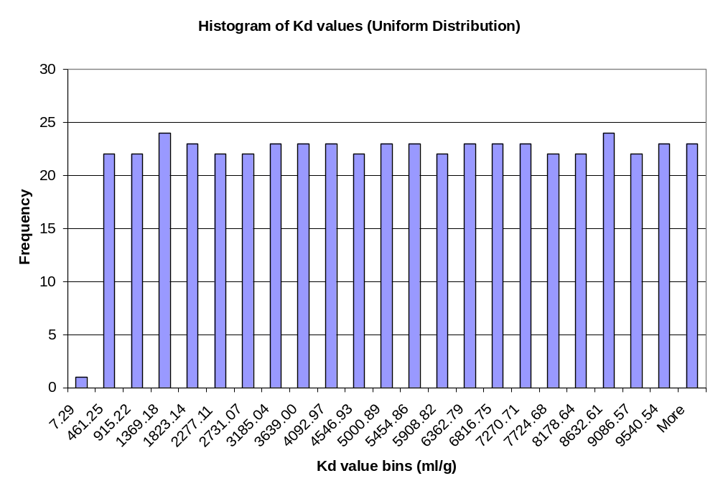
The statistical test performed on the results was the Komogorov-Smornoff test, which is a method to test goodness of fit of a set of data. It uses the hypothetical distribution and parameters for that distribution and compares it to the actual output data. The null hypothesis is that the distribution is, indeed, the one that is being claimed. The alternative hypothesis is that the distribution is not the one being claimed. If there is not enough evidence to reject the null hypothesis, then the resulting p-value will be high. As seen below, the p-value is equal to 1, the highest it can possibly be. Therefore, the null hypothesis was not rejected.

One-sample Kolmogorov-Smirnov Test
Hypothesized distribution = uniform

data: Uniform in data
ks = 0.0021, p-value = 1
alternative hypothesis: True cdf is not the uniform distn. with the specified parameters

3.6 SUM3_06

3.6.1 Description and Rationale

This case tests the ability of SUM³ to properly generate parameter values using the log uniform distribution type. Only the contaminant selection and source term modules will be used along with the SUM3 module. The constituent benzene was selected for this case. The Kd for benzene in the source term module will be selected as the parameter to vary using the log uniform distribution. The specific requirements checked are listed below. These requirement numbers are referenced in the Observed Results section. (Note: the requirement numbers used below do not correspond to the requirement numbers listed in Table 1.)

- allow the user to specify a distribution type for each selected variable from a list containing the following distribution types:
- Uniform
- Log Uniform
- Normal
- Log Normal
- prompt the user for input specifying the parameters of the distribution for each selected variable; these parameters will be a function of the distribution type.
- generate distributions for the selected input variables that statistically approximate the distributions specified by the user, including any correlations between variables.

3.6.2 Input Data

This section lists the input parameter values for this case. The contaminant benzene will be used as the contaminant for this test case. The following tables list the input for the MEPAS CSTRM:

Tab Name: Options
Description | Parameter Name | Parameter Value | Unit
Source term media | STMEDIA | Soil/Vadose | none
Leaching | STINF_OP | Known infiltration rate | none
Overland runoff | STOVL_OP | Turn off pathway | none
Suspension | STSUS_OP | Turn off pathway | none
Volatilization | STVOL_OP | Turn off pathway | none
Source/sink | STSRC_OP | Turn off pathway | none
Time interval for first 100 yrs | STDELTA_T | 1 | nears
Length of run | STMAXTIME | 100 | years
Minimum waste fraction | STMINWST | 0.01 | fraction

Tab Name: Waste Zone
Description | Parameter Name | Parameter Value | Unit
Depth to top of waste zone | STCLEAN | 0 | cm
Thickness of waste zone | STTHICK | 10 | m
Length of waste zone | STLENGTH | 10 | m
Width of waste zone | STWIDTH | 10 | m
Bulk density of soil | STZBULKD | 1.4 | g/cm3
Total porosity | STTOTPOR | 43.7 | percent
Moisture content | STMOISTC | 6 | percent
Volumetric air content | STAIRSPC | 37.7 | percent
Average air temperature at the waste site | STAVTEMP | 25 | C
Height above ground of local wind measure | STWINDHT | 10 | meters

Tab Name: Kds
Description | Count | Parameter Name | Parameter Value | Unit
equilibrium coefficient | 2 | STKD | 0.0 | ml/g
 |  | STKD | 0.0 | ml/g

Tab Name: Contaminant Properties
Description | Parameter Name | Parameter Value | Unit
water solubility | STSOL | 1750.0 | mg/L
contaminant inventory (use worksheet) | STINVEN | 1000.0 | g
decay/degradation half life | STGHALF | 0.0 | day

Tab Name: Known Media Releases
Description | Parameter Name | # of Measurements | Parameter Value | Year of Measurement | Unit
darcy infiltration rate | STDARCY | 2 | 10 | 0 | cm/yr
 |  |  | 10 | 100

The following tables list the input for SUMMM:

Tab Name: Variables
Description |  |  | alias
equilibrium coefficient, Benzene, Time # 1… |  |  | Kd1
Tab Name: Parameters
Subtab: Distribution (Correlations and Equation tabs will not be used)
Alias | Description | Distribution |  | Parameter Value | Unit
Kd1 | Upper bound | Log Uniform |  | 1.0E+5 | ml/g
Kd1 | Lower bound |  |  | 1.0E-5 | ml/g
Tab Name: Outputs
Description |  | Parameter Value |  | Unit
Random seed value |  | 11301 |  | none
Number of iterations |  | 10 |  | none
Water contaminant flux peak… |  | (alias) flux |  | none

3.6.3 Instructions for performing the test

General instructions for setting up a case and using FRAMES are located in Appendix A. They should be referenced if necessary. A detailed description of how to start up and execute this case will not be included here.

- Bring up the FUI and use the File menu to open the case SUM3_06.GID. It will be located in the folder labeled SUM3_06.
- The case SUM3_06.GID should contain a contaminant selection, source term, and sensitivity/uncertainty icons in the working space. The contaminant benzene has already been selected and the source term and SUM3 data have been entered already.
- Check the data entered for the source term module to ensure that it matches the data listed in section 3.6.2 above. Make corrections if necessary.
- Check the data entered for SUM3 to ensure that it matches the data listed in section 3.6.2 above. Make corrections if necessary.
- Run the source term module to get green lights for each. This should be done even if the light is already green. Then run SUM3.
- After the run has completed, use the viewer connected to the sensitivity/uncertainty icon to check that all 10 iterations were completed successfully. The actual numbers are not important for this case.
- Save and exit this case.
- The result file for this case will be called 'SUM3_06.SUF. It is a comma-separated file and can be read using MS Excel or other spreadsheet programs. Use one of these spreadsheet programs to plot the results of the run 'iteration number vs. Kd value'. The points should be evenly scattered in the plot area. This would indicate that values are uniformly distributed over the specified range.

3.6.4 Expected Results

It is expected that SUM3 will allow the user to select the log uniform distribution type, prompt the user for the required distribution data, and will generate parameter values for the benzene Kd using the uniform distribution type. The values generated will be plotted and a visual inspection will be made of the results.

3.6.5 Observed Results

SUM3 allowed the user to select the log uniform distribution type, prompted the user for the required distribution data, and generated parameter values for the benzene Kd using the log uniform distribution type. The values generated were plotted and the plots are listed below. The first plot is the histogram of the raw data. The second plot is the histogram of the log of the raw data. As can be seen in the second figure, the points are uniformly distributed over the plot area, which indicates that the uniform distribution was used.

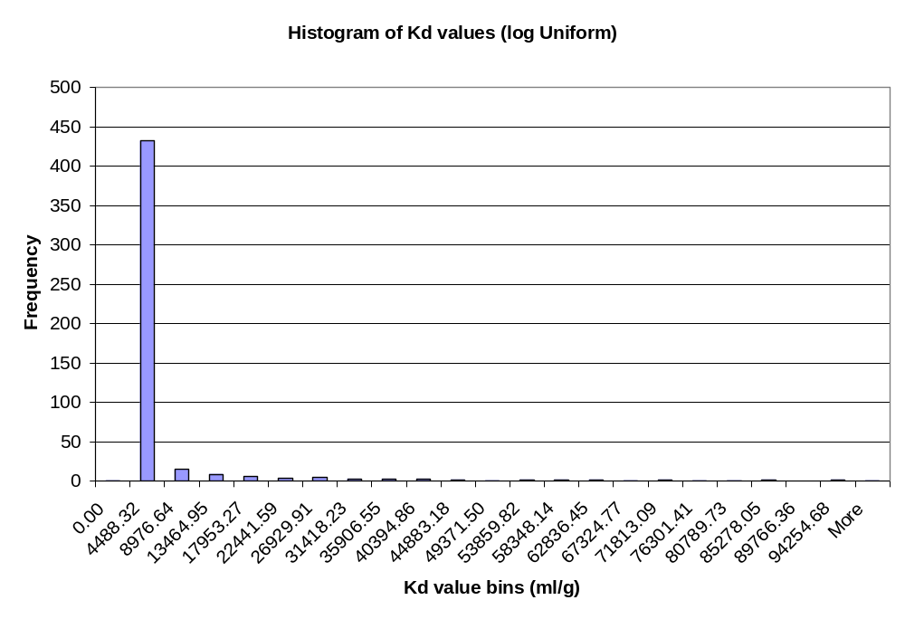
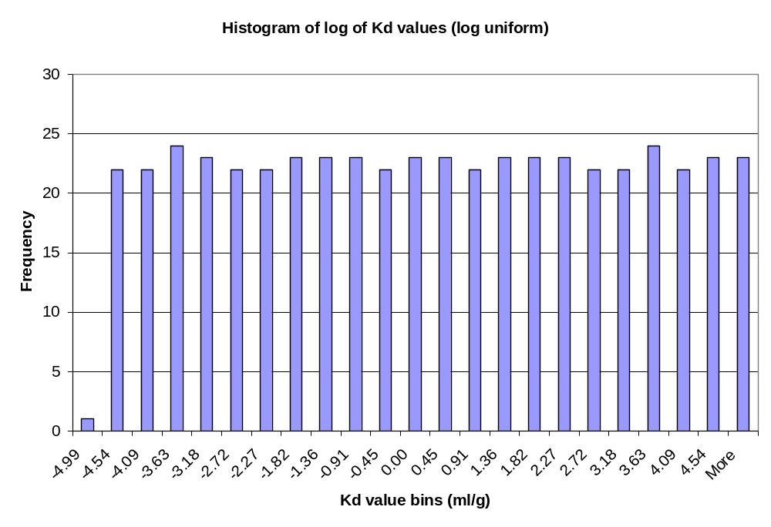

3.7 SUM3_07

3.7.1 Description and Rationale

This case tests the ability of SUM³ to properly generate parameter values using the normal distribution type. The requirement that the system will run up to 500 iterations will also be checked in this test case. Only the contaminant selection and source term modules will be used along with the SUM3 module. The constituent benzene was selected for this case. The Kd for benzene in the source term module will be selected as the parameter to vary using the normal distribution. The specific requirements checked are listed below. These requirement numbers are referenced in the Observed Results section. (Note: the requirement numbers used below do not correspond to the requirement numbers listed in Table 1.)

- allow the user to specify a distribution type for each selected variable from a list containing the following distribution types:
- Uniform
- Log Uniform
- Normal
- Log Normal
- prompt the user for input specifying the parameters of the distribution for each selected variable; these parameters will be a function of the distribution type.
- generate distributions for the selected input variables that statistically approximate the distributions specified by the user, including any correlations between variables.

3.7.2 Input Data

This section lists the input parameter values for this case. The contaminant benzene will be used as the contaminant for this test case. The following tables list the input for the MEPAS CSTRM:

Tab Name: Options
Description | Parameter Name | Parameter Value | Unit
Source term media | STMEDIA | Soil/Vadose | none
Leaching | STINF_OP | Known infiltration rate | none
Overland runoff | STOVL_OP | Turn off pathway | none
Suspension | STSUS_OP | Turn off pathway | none
Volatilization | STVOL_OP | Turn off pathway | none
Source/sink | STSRC_OP | Turn off pathway | none
Time interval for first 100 yrs | STDELTA_T | 1 | nears
Length of run | STMAXTIME | 100 | years
Minimum waste fraction | STMINWST | 0.01 | fraction

Tab Name: Waste Zone
Description | Parameter Name | Parameter Value | Unit
Depth to top of waste zone | STCLEAN | 0 | cm
Thickness of waste zone | STTHICK | 10 | m
Length of waste zone | STLENGTH | 10 | m
Width of waste zone | STWIDTH | 10 | m
Bulk density of soil | STZBULKD | 1.4 | g/cm3
Total porosity | STTOTPOR | 43.7 | percent
Moisture content | STMOISTC | 6 | percent
Volumetric air content | STAIRSPC | 37.7 | percent
Average air temperature at the waste site | STAVTEMP | 25 | C
Height above ground of local wind measure | STWINDHT | 10 | meters

Tab Name: Kds
Description | Count | Parameter Name | Parameter Value | Unit
equilibrium coefficient | 2 | STKD | 0.0 | ml/g
 |  | STKD | 0.0 | ml/g

Tab Name: Contaminant Properties
Description | Parameter Name | Parameter Value | Unit
water solubility | STSOL | 1750.0 | mg/L
contaminant inventory (use worksheet) | STINVEN | 1000.0 | g
decay/degradation half life | STGHALF | 0.0 | day

Tab Name: Known Media Releases
Description | Parameter Name | # of Measurements | Parameter Value | Year of Measurement | Unit
darcy infiltration rate | STDARCY | 2 | 10 | 0 | cm/yr
 |  |  | 10 | 100

The following tables list the input for SUMMM:

Tab Name: Variables
Description |  |  | alias
equilibrium coefficient, Benzene, Time # 1… |  |  | Kd1
Tab Name: Parameters
Subtab: Distribution (Correlations and Equation tabs will not be used)
Alias | Description | Distribution |  | Parameter Value | Unit
Kd1 | Upper bound | Normal |  | 2000 | ml/g
 | Lower bound | Normal |  | 1 | ml/g
 | Mean | Normal |  | 1000 | ml/g
 | Standard deviation | Normal |  | 260 | ml/g
Tab Name: Outputs
Description |  | Parameter Value |  | Unit
Random seed value |  | 11301 |  | none
Number of iterations |  | 500 |  | none
Water contaminant flux peak… |  | (alias) flux |  | none

3.7.3 Instructions for performing the test

General instructions for setting up a case and using FRAMES are located in Appendix A. They should be referenced if necessary. A detailed description of how to start up and execute this case will not be included here.

- Bring up the FUI and use the File menu to open the case SUM3_07.GID. It will be located in the folder labeled SUM3_07.
- Open up the case SUM3_07.GID that should contain a contaminant selection, source term, and sensitivity/uncertainty icons in the working space. The contaminant benzene has already been selected and the source term and SUM3 data have been entered already.
- Check the data entered for the source term module to ensure that it matches the data listed in section 3.7.2 above. Make corrections if necessary.
- Check the data entered for SUM3 to ensure that it matches the data listed in section 3.7.2 above. Make corrections if necessary.
- Run the source term module to get green lights for each. This should be done even if the light is already green. Then run SUM3.
- After the run has completed, use the viewer connected to the sensitivity/uncertainty icon to check that all 10 iterations were completed successfully. The actual numbers are not important for this case.
- Save and exit this case.
- The result file for this case will be called 'SUM3_07.SUF. It is a comma-separated file and can be read using MS Excel or other spreadsheet programs. Use one of these spreadsheet programs to plot the results of the run 'iteration number vs. Kd value'. The points should be evenly scattered in the plot area. This would indicate that values are uniformly distributed over the specified range.

3.7.4 Expected Results

It is expected that SUM3 will allow the user to select the normal distribution type, prompt the user for the required distribution data, and will generate parameter values for the benzene Kd using the uniform distribution type. The values generated will be plotted and a visual inspection will be made of the results. It is also expected that the model will allow the user to specify 500 iterations and that the model will perform 500 iterations.

3.7.5 Observed Results

SUM3 allowed the user to select the normal distribution type, prompted the user for the required distribution data, allowed the user to select 500 iterations, and generated 500 parameter values for the benzene Kd using the normal distribution type. The values generated were plotted and the plot is listed below. As can be seen, the points are uniformly distributed over the plot area, which indicates that the uniform distribution was used.

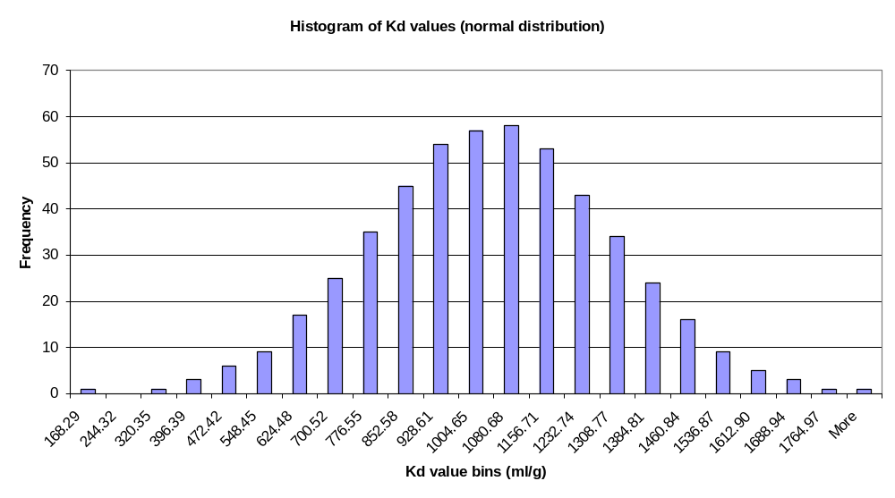
The statistical test performed on the results was the Komogorov-Smornoff test, which is a method to test goodness of fit of a set of data. It uses the hypothetical distribution and parameters for that distribution and compares it to the actual output data. The null hypothesis is that the distribution is, indeed, the one that is being claimed. The alternative hypothesis is that the distribution is not the one being claimed. If there is not enough evidence to reject the null hypothesis, then the resulting p-value will be high. As seen below, the p-value is equal to 1, the highest it can possibly be. Therefore, the null hypothesis was not rejected.

One-sample Kolmogorov-Smirnov Test
Hypothesized distribution = normal

data: Normal in data
ks = 0.0093, p-value = 1
alternative hypothesis:
True cdf is not the normal distn. with the specified parameters

3.8 SUM3_08

3.8.1 Description and Rationale

This case tests the ability of SUM³ to properly generate parameter values using the log normal distribution type. Only the contaminant selection and source term modules will be used along with the SUM3 module. The constituent benzene was selected for this case. The Kd for benzene in the source term module will be selected as the parameter to vary using the log normal distribution. The specific requirements checked are listed below. These requirement numbers are referenced in the Observed Results section. (Note: the requirement numbers used below do not correspond to the requirement numbers listed in Table 1.)

- allow the user to specify a distribution type for each selected variable from a list containing the following distribution types:
- Uniform
- Log Uniform
- Normal
- Log Normal
- prompt the user for input specifying the parameters of the distribution for each selected variable; these parameters will be a function of the distribution type.
- generate distributions for the selected input variables that statistically approximate the distributions specified by the user, including any correlations between variables.

3.8.2 Input Data

This section lists the input parameter values for this case. The contaminant benzene will be used as the contaminant for this test case. The following tables list the input for the MEPAS CSTRM:

Tab Name: Options
Description | Parameter Name | Parameter Value | Unit
Source term media | STMEDIA | Soil/Vadose | none
Leaching | STINF_OP | Known infiltration rate | none
Overland runoff | STOVL_OP | Turn off pathway | none
Suspension | STSUS_OP | Turn off pathway | none
Volatilization | STVOL_OP | Turn off pathway | none
Source/sink | STSRC_OP | Turn off pathway | none
Time interval for first 100 yrs | STDELTA_T | 1 | nears
Length of run | STMAXTIME | 100 | years
Minimum waste fraction | STMINWST | 0.01 | fraction

Tab Name: Waste Zone
Description | Parameter Name | Parameter Value | Unit
Depth to top of waste zone | STCLEAN | 0 | cm
Thickness of waste zone | STTHICK | 10 | m
Length of waste zone | STLENGTH | 10 | m
Width of waste zone | STWIDTH | 10 | m
Bulk density of soil | STZBULKD | 1.4 | g/cm3
Total porosity | STTOTPOR | 43.7 | percent
Moisture content | STMOISTC | 6 | percent
Volumetric air content | STAIRSPC | 37.7 | percent
Average air temperature at the waste site | STAVTEMP | 25 | C
Height above ground of local wind measure | STWINDHT | 10 | meters

Tab Name: Kds
Description | Count | Parameter Name | Parameter Value | Unit
equilibrium coefficient | 2 | STKD | 0.0 | ml/g
 |  | STKD | 0.0 | ml/g

Tab Name: Contaminant Properties
Description | Parameter Name | Parameter Value | Unit
water solubility | STSOL | 1750.0 | mg/L
contaminant inventory (use worksheet) | STINVEN | 1000.0 | g
decay/degradation half life | STGHALF | 0.0 | day

Tab Name: Known Media Releases
Description | Parameter Name | # of Measurements | Parameter Value | Year of Measurement | Unit
darcy infiltration rate | STDARCY | 2 | 10 | 0 | cm/yr
 |  |  | 10 | 100

The following tables list the input for SUMMM:

Tab Name: Variables
Description |  |  | alias
equilibrium coefficient, Benzene, Time # 1… |  |  | Kd1
Tab Name: Parameters
Subtab: Distribution (Correlations and Equation tabs will not be used)
Alias | Description | Distribution |  | Parameter Value | Unit
Kd1 | Upper bound (linear) | Log Normal |  | 250 | ml/g
 | Lower bound (linear) | Log Normal |  | 1 | ml/g
 | mean log | Log Normal |  | 1.1 | ml/g
 | Std Dev. | Log Normal |  | 0.3 | ml/g
 | Log Base | Log Normal |  | Base 10 | none
Tab Name: Outputs
Description |  | Parameter Value |  | Unit
Random seed value |  | 11301 |  | none
Number of iterations |  | 500 |  | none
Water contaminant flux peak… |  | (alias) flux |  | none

3.8.3 Instructions for performing the test

General instructions for setting up a case and using FRAMES are located in Appendix A. They should be referenced if necessary. A detailed description of how to start up and execute this case will not be included here.

- Bring up the FUI and use the File menu to open the case SUM3_08.GID. It will be located in the folder labeled SUM3_08.
- Open up the case SUM3_08.GID that should contain a contaminant selection, source term, and sensitivity/uncertainty icons in the working space. The contaminant benzene has already been selected and the source term and SUM3 data have been entered already.
- Check the data entered for the source term module to ensure that it matches the data listed in section 3.8.2 above. Make corrections if necessary.
- Check the data entered for SUM3 to ensure that it matches the data listed in section 3.8.2 above. Make corrections if necessary.
- Run the source term module to get green lights for each. This should be done even if the light is already green. Then run SUM3.
- After the run has completed, use the viewer connected to the sensitivity/uncertainty icon to check that all 10 iterations were completed successfully. The actual numbers are not important for this case.
- Save and exit this case.
- The result file for this case will be called 'SUM3_08.SUF. It is a comma-separated file and can be read using MS Excel or other spreadsheet programs. Use one of these spreadsheet programs to plot the results of the run 'iteration number vs. Kd value'. The points should be evenly scattered in the plot area. This would indicate that values are uniformly distributed over the specified range.

3.8.4 Expected Results

It is expected that SUM3 will allow the user to select the log normal distribution type, prompt the user for the required distribution data, and will generate parameter values for the benzene Kd using the uniform distribution type. The values generated will be plotted and a visual inspection will be made of the results.

3.8.5 Observed Results

SUM3 allowed the user to select the log normal distribution type, prompted the user for the required distribution data, and generated parameter values for the benzene Kd using the uniform distribution type.
The values generated were plotted and the plots are listed below. The first plot is the histogram of the raw data. The second plot is the histogram of the log of the raw data. As can be seen in the second figure, the points are normally distributed over the plot area, which indicates that the log normal distribution was used.

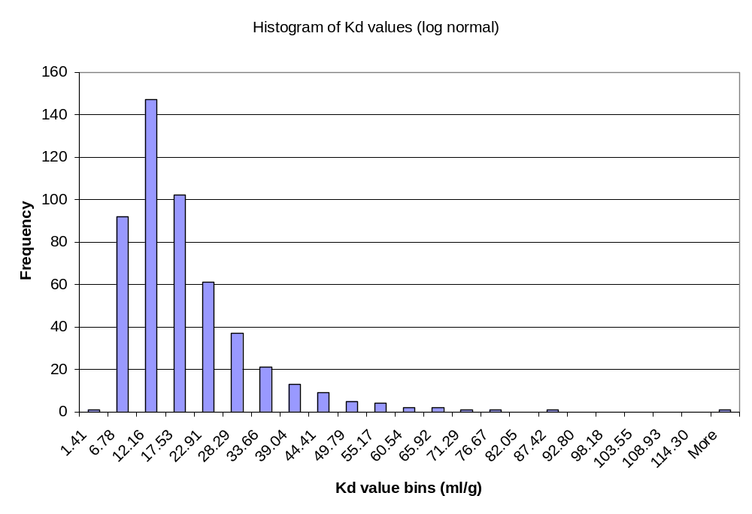
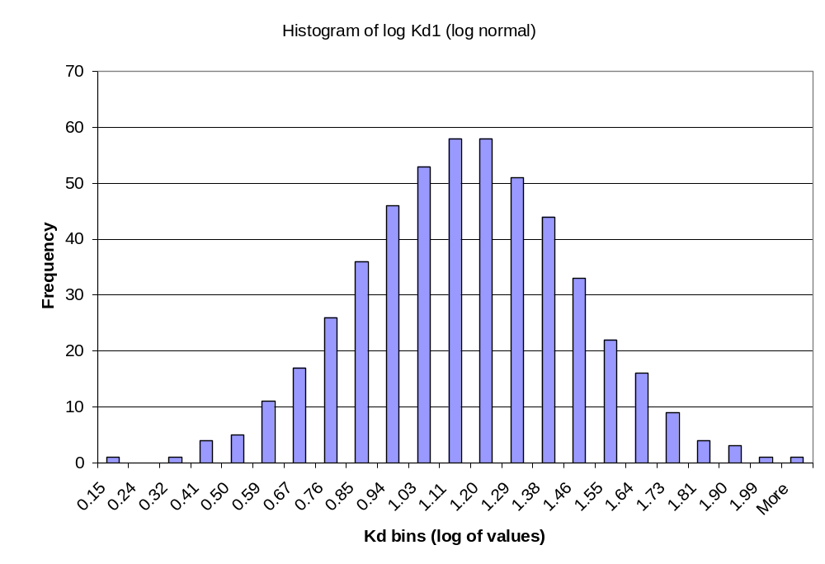
Summary Statistics were computed on the results. The mean of the log values sampled was 1.1 and the standard deviation was 0.3. Both numbers matched the parameter values entered.

3.9 SUM3_09

3.9.1 Description and Rationale

The purpose of this test case is to verify that the SUMMM will allow the user to select peak cumulative dose results as an output choice and correctly computes the peak cumulative dose result for each modeling iteration. The peak dose result reported should include the cumulative dose peak for all constituents, all decay products, for all pathways and the time of the peak dose. In this case, Sr-90 and U-235 were selected as constituents. The pathways selected were drinking water and meat ingestion.

3.9.2 Input Data

This section lists the input parameter values for this case. The constituents Sr-90 and U-235 will be used as the constituents for this test case. The following tables list the input for the module used:

FRAMES User Defined Module (wcf.Aquifer)
Constituent | Time (yr) | Concentration (pCi/ml)
Sr-90 | 0 | 5
Sr-90 | 30 | 10
Sr-90 | 60 | 15
U-235 | 0 | 1
U-235 | 30 | 2
U-235 | 60 | 3

MEPAS Chronic Exposure Module
Exposure Controls Tab
EC-TEXPOS | 0.0 yr | EC-LEACHOPTION |  |  | User provided leach rate const.
EC-MAXTIM | 120.0 yr | benzene |  |  | 50 1/yr
EC-NTIMES | 4

Leach Rates Tab
EC-LEACHOPTION |  |  | User provided leach rate const.
SOILLR |  |  | 100 1/yr (For all constituents and progeny)

Ground Water Tab
EG-DGWED |  |  | 30.0 yr
Water Usage subtab |  |  |  | Pathways subtab
Animal Drinking |  | X |  | meat
Irrigation of animal feed |  | X |  | drinking water
EG-FIRR |  | 1.0
EG-CIRR |  | 100.0 L/m^2/m
EG-TWIR |  | 0.5 d
Domestic water is treated

MEPAS Intake Module
Body weight of individual | 70 kg
Exposure duration | 30 years
Water dermal absorption model | EPA model
Drinking water ingestion rate (surface water) | 2.0 L/d
Drinking water ingestion rate (ground water) | 2.0 L/d
Age of receptor at start of exposure | 0 yr
Age of receptor at end of exposure | 70 yr

MEPAS Health Impact Module
Chemical tab |  | Radionuclide tab
CHEMRISK |  | HE-INC
CHEMHI | X | HE-CONINC
RFDLIM | 0.0 | HE-FAT
Inhale | Air Concentration | HE-CONFAT
Inhale | Air Concentration | HE-FSH
 |  | HE-CONFSH
 |  | HE-CEDE | X
 |  | Cancer risk evaluation method | EPA HEAST radionuclide slope factors

The following tables list the input for SUMMM:

Tab Name: Variables
Description |  |  | alias
Groundwater ingestion rate |  |  | GwDrink
Tab Name: Parameters
Subtab: Distribution (Correlations and Equation tabs will not be used)
Alias | Description | Distribution |  | Parameter Value | Unit
GwDrink | Upper bound | Uniform |  | 4.0 | L/d
GwDrink | Lower bound |  |  | 0.1 | L/d
Tab Name: Outputs
Description |  | Parameter Value |  | Unit
Random seed value |  | 11301 |  | none
Number of iterations |  | 3 |  | none
Cumulative dose peak |  | (alias) DoseAll |  | none

3.9.3 Instructions for performing the test

- Bring up the FUI and use the File menu to open the case SUM3_09.GID. It will be located in the folder labeled SUM3_09.
- Open up the case SUM3_09.GID that should contain a contaminant selection, user defined source, exposure, receptor intake, health impacts, and sensitivity/uncertainty icons in the working space. The contaminants Sr-90 and U-235 have already been selected and all data have been entered already.
- Check the data entered for the modules to ensure that it matches the data listed in section 3.9.2 above. Make corrections if necessary.
- Run the modules to get green lights for each. This should be done even if the lights are already green. Then run SUM3.
- After the run has completed, use the viewer connected to the sensitivity/uncertainty icon to check that all 3 iterations were completed successfully.
- Check the file SUM3_09.SUF file to verify that the results match the expected results that were hand calculated.
- Save and exit this case.

3.9.4 Expected Results

Hand calculations were performed to predict the results of this test case. The hand calculations are included in the test package in the files sum3_09a_hif.xls, sum3_09b_hif.xls, and sum3_09c_hif.xls. The expected results are listed in the following table:

Iteration | Cumulative Dose Peak (Sv) | Dose Peak Time (yr)
1 | 0.997 | 30
2 | 0.888 | 30
3 | 0.660 | 30

3.9.5 Observed Results

The SUF file created in this case is listed below. As can be seen, the results for each iteration match well with the expected results. The file format is realization, drinking water rate, peak dose time, peak dose.

File: Sum3_09.suf

"sen2",11
2
"Sensitivity/Uncertainty Module for FRAMES"
"Beta Test version"
1,1
"GwDrink","Goundwater ingestion rate from rcp5"
"DoseAll","Cumulative dose peak from hei4 for all [chronic.usr7.Aquifer]"
3
"realizations","GwDrink","DoseAll peak time","DoseAll"
1,"3.6668E-01",30,0.09966682127
2,"3.2951E+00",30,0.8881389574
3,"2.4433E+00",30,0.6595309468

3.10 SUM3_10

3.10.1 Description and Rationale

The purpose of this test case is to confirm that the SUMMM module appropriately handles module errors and its own errors. Both types of error handling will be tested in this test case. In the first part of the test case, a file required by the receptor module will be removed and thus the module will fail. In the second part of this test case, the results from the health impact module will be deleted after the run. SUMMM will be looking to access this file in order to read results from it. This should cause SUMMM to error out.

3.10.2 Input Data

This section lists the input parameter values for this case. The constituents Sr-90 and U-235 will be used as the constituents for this test case. The following tables list the input for the module used:

FRAMES User Defined Module (wcf.Aquifer)
Constituent | Time (yr) | Concentration (pCi/ml)
Sr-90 | 0 | 5
Sr-90 | 30 | 10
Sr-90 | 60 | 15
U-235 | 0 | 1
U-235 | 30 | 2
U-235 | 60 | 3

MEPAS Chronic Exposure Module
Exposure Controls Tab
EC-TEXPOS | 0.0 yr | EC-LEACHOPTION |  |  | User provided leach rate const.
EC-MAXTIM | 120.0 yr | benzene |  |  | 50 1/yr
EC-NTIMES | 4

Leach Rates Tab
EC-LEACHOPTION |  |  | User provided leach rate const.
SOILLR |  |  | 100 1/yr (For all constituents and progeny)

Ground Water Tab
EG-DGWED |  |  | 30.0 yr
Water Usage subtab |  |  |  | Pathways subtab
Animal Drinking |  | X |  | meat
Irrigation of animal feed |  | X |  | drinking water
EG-FIRR |  | 1.0
EG-CIRR |  | 100.0 L/m^2/m
EG-TWIR |  | 0.5 d
Domestic water is treated

MEPAS Intake Module
Body weight of individual | 70 kg
Exposure duration | 30 years
Water dermal absorption model | EPA model
Drinking water ingestion rate (surface water) | 2.0 L/d
Drinking water ingestion rate (ground water) | 2.0 L/d
Age of receptor at start of exposure | 0 yr
Age of receptor at end of exposure | 70 yr

MEPAS Health Impact Module
Chemical tab |  | Radionuclide tab
CHEMRISK |  | HE-INC
CHEMHI | X | HE-CONINC
RFDLIM | 0.0 | HE-FAT
Inhale | Air Concentration | HE-CONFAT
Inhale | Air Concentration | HE-FSH
 |  | HE-CONFSH
 |  | HE-CEDE | X
 |  | Cancer risk evaluation method | EPA HEAST radionuclide slope factors

The following tables list the input for SUMMM:

Tab Name: Variables
Description |  |  | alias
Groundwater ingestion rate |  |  | GwDrink
Tab Name: Parameters
Subtab: Distribution (Correlations and Equation tabs will not be used)
Alias | Description | Distribution |  | Parameter Value | Unit
GwDrink | Upper bound | Uniform |  | 4.0 | L/d
GwDrink | Lower bound |  |  | 0.1 | L/d
Tab Name: Outputs
Description |  | Parameter Value |  | Unit
Random seed value |  | 11301 |  | none
Number of iterations |  | 3 |  | none
Cumulative dose peak |  | (alias) DoseAll |  | none

3.10.3 Instructions for performing the test

- Bring up the FUI and use the File menu to open the case SUM3_10.GID. It will be located in the folder labeled SUM3_10.
- Open up the case SUM3_10.GID that should contain a contaminant selection, saturated zone, exposure, receptor, health impacts and sensitivity/uncertainty icons in the working space. The constituents Sr-90 and U-235 have already been selected and all module and SUM3 data have been entered already.
- Check the data entered for the modules and SUM3 to ensure that it matches the data listed in section 3.10.2 above. Make corrections if necessary.
- Run the each of the modules again to get green lights for each. This should be done even if the lights are already green.
- To cause module error you will need to perform some file manipulations. Using Windows Explorer, change the name of the file ‘meprcp.bat’ to ‘meprcpOLD.bat’.
- Using Windows Explorer, change the name of the file ‘meprcpT10.bat’ to ‘meprcp.bat’. The new meprcp.bat has a pause in it that will allow you to modify files during the SUM3 run.
- Then run SUM3.
- When the DOS window appears, hit any key and it will close and SUM3 will continue running.
- The second time the DOS window appears, use Windows explorer to find the file ‘~sens.epf’. The file should be located in the same folder as the Sum3_10.gid file. Delete the ‘~sens.epf’ file.
- When prompted, confirm the delete.
- Click on the DOS window and hit any key. SUM3 should continue running.
- When the DOS window appears for the third time, hit any key and it will close and SUM3 will run to completion.
- All module signal lights should now be green. Right click on the SUM3 icon and use the SUF text viewer to view the results.
- Check that there are output results for the first iteration but not for the second and third. This is expected because before the second and third iterations, you deleted a file that the receptor module needed as input and therefore it errored out and did not produce results.
- Change the receptor module batch file back to the original. Using Windows Explorer, change the name of the file ‘meprcp.bat’ to ‘meprcpT10.bat’.
- Using Windows Explorer, change the name of the file ‘meprcpOLD.bat’ to ‘meprcp.bat’.
- You will next make some modifications to cause SUM3 to error. Using Windows Explorer, change the name of the file ‘mephei.bat’ to ‘meprcpOLD.bat’.
- Using Windows Explorer, change the name of the file ‘mepheiT10.bat’ to ‘mephei.bat’. The new mephei.bat has a pause in it that will allow you to modify files during the SUM3 run.
- Run the each of the modules again to get green lights for each. This should be done even if the lights are already green.
- Then run SUM3.
- When the DOS window appears, use Windows explorer to find the files ‘~sens.hif’ and ‘~sens0.hif’. The files should be located in the same folder as the Sum3_10.gid file. Delete both files.
- When prompted, confirm the delete.
- Click on the DOS window and hit any key. SUM3 should continue running.
- An error message should appear and the SUM3 run will halt.
- Click ‘ok’ to close the error message window. Note that the signal light on the SUM3 icon remained yellow.
- Change the receptor module batch file back to the original. Using Windows Explorer, change the name of the file ‘mephei.bat’ to ‘mepheiT10.bat’.
- Using Windows Explorer, change the name of the file ‘mepheiOLD.bat’ to ‘mephei.bat’.
- Save and exit this case.

3.10.4 Expected Results

Module Error

When a module error occurs during a SUM3 run, it is expected that SUM3 will not write out the results for that iteration but will continue on with the other iterations that were requested. The input values for the iteration that errored will be preserved so that the user can go back and reproduce the error in a deterministic run. The expected results for this part of the test case should look as follows:

SUM3_10.SUF

********************************************************************************
* File: c:\frames\sum3_10\sum3_10.suf
* Section: sen2
* Date: 10/1/2003 5:03:40 PM
********************************************************************************

2
"Sensitivity/Uncertainty Module for FRAMES"
"Beta Test version"
1,2
"GwDrink","Goundwater ingestion rate from rcp5"
"DoseAll","Cumulative dose peak from hei4 for all [chronic.usr7.Aquifer]"
"can","Cancer incidence peak from hei4 for STRONTIUM-90 [chronic.usr7.Aquifer]"
3
"realizations","GwDrink","DoseAll peak time","DoseAll","can peak time","can"
1,"3.6668E-01",30,0.09966682127,30,0.0020793
2,"3.2951E+00"
3,"2.4433E+00"

SUM3 Error

When a SUM3 error occurs during a SUM3 run, it is expected that SUM3 will halt execution and write out an error message.

3.10.5 Observed Results

The results observed matched those described in Section 3.10.4.

Appendix A - General Procedure for Test Case Implementation

This section contains general instructions for setting up and running test cases. In most cases, the Global Input Data (GID) file for each case has been completed beforehand and needs no editing by the user. Some cases may need some editing by the user to test certain functionalities. For cases where the tester will be required to put together a case, the following instructions will be useful:

- Clearing the Frames User Interface (FUI) screen to start a new case

These instructions assume that the FUI window is up on the user’s screen. If the window area below the icons is not clear, go to the upper left-hand corner to the ‘File’ drag down menu and select the ‘New’ option. You will be prompted to save the current file. Select ‘yes’ and follow prompts to save the case or ‘no’ to discard the current case. Once the window is clear, you may begin a new case.

- Picking a contaminant and naming the case file

Click on the contaminant selection icon. The icon should appear in the worksheet section of the screen along with a signal light that will be black. The black light indicates that a contaminant database has not been selected. Once the database has been selected, the light will turn red indicating that a database has been selected but no contaminants have been selected. Once the database and contaminants are selected, the light will turn green indicating that the module has been completed. Double click on the contaminants icon. A screen titled ‘Object General Information’ will appear. The section titled ‘Select from Model List’ contains a list of databases that can be used in the FRAMES system. Single click on the FRAMES Default Chemical Database Selection. A description will appear in the ‘Model Description’ section to the right. Then click ‘ok’ at the bottom of the screen. You will then be prompted to provide a name and select a location for the file. When done entering a file name and selecting a file location, click ‘ok’ at the bottom of the screen. A new screen titled ‘Contaminant Selection’ will appear. The contaminants of interest must be chosen using this screen. Several categories of contaminants may be chosen. The default category is ‘All Contaminants’. The other categories may be selected by single clicking on the button to the right of the ‘Select from Possible Contaminants:’ box. The contaminants selected for all test cases were chosen from the ‘All Contaminants’ list.

To select a contaminant, click on the ‘Find’ button, type in the contaminant name, and click ‘ok’. The first contaminant containing the contaminant name will be highlighted in the list to the right. For example, if you typed in ‘benzene’, ‘1,2 Dichlorobenzene’ would be highlighted because it contains the word string ‘benzene’. Since it is not the contaminant of interest, you would click on ‘Again’ and the next contaminant containing ‘benzene’ would be highlighted. You would continue to click ‘ok’ until plain ‘benzene’ was highlighted. You would then click on ‘Select’ and it would be added to the list of contaminants that will be used, which is located to the right. Additional contaminants can be added by following the same process. A contaminant may be removed from the list by highlighting the contaminant in the list to the right and clicking ‘Remove’. When the list is complete, click ‘ok’. The contaminant selection screen will disappear and the signal light attached to the Contaminants icon will change to green instead of red indicating that contaminant selection is complete.

- Dropping an icon into the workspace

In FRAMES, modeling scenarios are compartmentalized into media specific objects (i.e., source term, air, groundwater, etc…). These objects are represented by icons in the FRAMES system and conceptual site models are developed using these icons to describe the flow of information through the modeling system (e.g., source → aquifer → exposure location → receptors → human health impacts).

To determine the media represented by each icon, move the cursor over each icon. A caption indicating the module type will appear. To add an icon to the workspace, single click on the icon and drag it into the worksheet area to the location that you want it. The icon will appear along with a signal light which will be black. The black light indicates that a model has not been chosen.

- Connecting module icons

When the icons that will make up the modeling scenario have been placed in the working space, you will need to connect them in order to specify the flow of data through the system (e.g., source → aquifer → exposure location → receptors → human health impacts). To connect two module icons, hold the 'shift' key down then place the cursor over the first module icon. Hold the 'shift' key down and press the right mouse key. Keep the mouse button pressed down and then drag the cursor over the second module icon and the release the mouse button. A line should appear between the two modules with an arrow indicating the direction of data flow. For example source data output to the vadose zone module. Some connections are not allowable in FRAMES. If you try to make one of these connections, the line will not appear and a message window providing an explanation will appear.

- Selecting a model and naming it

To select a model for a module icon, right click on the icon. A screen titled ‘Object General Information’ should appear. In the box titled ‘Label:’, type in a source module name. Then select a model from the list in the ‘Select from Applicable Models’ list box on the left. Single click on this module and click ‘ok’ at the bottom of the screen. The ‘Object General Information’ screen will disappear. The signal light on the icon should now be red.

- Entering model data and running the model

To enter the data required by a model, right click on the icon and select 'User Input'. The user interface for the model should appear. Fill in the required data and then save and exit the model user interface screen. The model user interface should disappear and the signal light on the icon should now be yellow. The yellow light indicates that the model is ready to be run.

To run the model, right click on the icon and select 'Run Model'. The model should execute. When the model is done executing, the signal light on the icon should turn green. The green light indicates that the model ran successfully. If the model does not run, FRAMES will provide a message indicating that a connecting model must be run first or that there was a model error.

Use the ‘File’ pull-down menu to save and exit. Notice that the signal light changed to yellow, which indicates that all data has been entered and the module is ready to be run. Next, right click on the source term icon and run the model. Notice that the signal light changed to green, which indicates that the model ran successfully.

- Viewing results of any module

The results of each module type may be viewed as text or graphically within FRAMES using one of the available file viewers. The results output files with the extensions .AFF, .WFF, .WCF. and .SCF can be viewed graphically if Microsoft Excel is installed on the user's computer. The results output files with the extensions .ATO, EPF, RIF, and HIF cannot be viewed graphically at this time.

To use a viewer, single click on the graph icon and drag it into the worksheet area near the icon of interest. Hold down the shift key and left mouse button and drag a line from the icon to the graph icon. A line with an arrow pointing to the viewer will appear. Double click on the chart icon. The ‘Object General Information’ screen will appear. In the box titled ‘Label:’, type in a viewer name. Then select what type of viewer you would like from the list in the ‘Select from Applicable Models’ list box on the left. After one of the modules is selected, click ‘ok’ at the bottom of the screen. The ‘Object General Information’ screen will close down. Then right click on the viewer icon and select ‘Run Model’. The viewer will display the file type that you choose. Close the window when you are finished with it. You can add multiple viewers to the same icon, by repeating the above process and selecting different viewer types. It is important to note that these viewers are not necessary. The results may be viewed using DOS, M.S. Excel, NotePad, and by other similar software packages.

- Saving and exiting the case

To exit the case, use the File pull-down menu in the upper left of the FUI screen. Select 'Save and Exit' or just 'Exit'. The FUI window will then shut down. If you would like to shut the case down to start a new case or open a different case, use the File pull-down menu and follow the instructions as prompted.

